The Waterfall Model was the first Process Model to be introduced. It is also referred to as a **linear-sequential life cycle model**. It is very simple to understand and use. In a waterfall model, each phase must be completed before the next phase can begin and there is no overlapping in the phases.

The Waterfall model is the earliest SDLC approach that was used for software development.

The waterfall Model illustrates the software development process in a linear sequential flow. This means that any phase in the development process begins only if the previous phase is complete. In this waterfall model, the phases do not overlap.

Waterfall Model - Design

Waterfall approach was first SDLC Model to be used widely in Software Engineering to ensure success of the project. In "The Waterfall" approach, the whole process of software development is divided into separate phases. In this Waterfall model, typically, the outcome of one phase acts as the input for the next phase sequentially.

The following illustration is a representation of the different phases of the Waterfall Model.

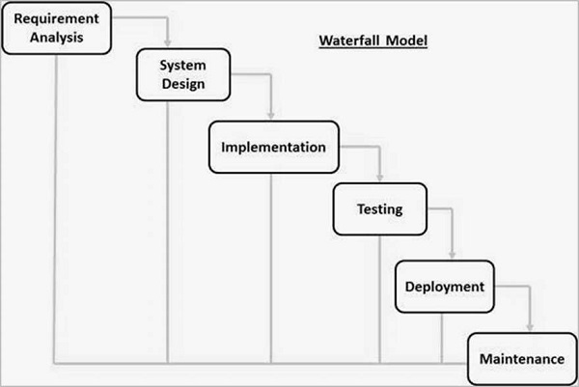

The sequential phases in Waterfall model are −

* **Requirement Gathering and analysis** − All possible requirements of the system to be developed are captured in this phase and documented in a requirement specification document.
* **System Design** − The requirement specifications from first phase are studied in this phase and the system design is prepared. This system design helps in specifying hardware and system requirements and helps in defining the overall system architecture.
* **Implementation** − With inputs from the system design, the system is first developed in small programs called units, which are integrated in the next phase. Each unit is developed and tested for its functionality, which is referred to as Unit Testing.
* **Integration and Testing** − All the units developed in the implementation phase are integrated into a system after testing of each unit. Post integration the entire system is tested for any faults and failures.
* **Deployment of system** − Once the functional and non-functional testing is done; the product is deployed in the customer environment or released into the market.
* **Maintenance** − There are some issues which come up in the client environment. To fix those issues, patches are released. Also to enhance the product some better versions are released. Maintenance is done to deliver these changes in the customer environment.

Some of the major advantages of the Waterfall Model are as follows −

* Simple and easy to understand and use
* Easy to manage due to the rigidity of the model. Each phase has specific deliverables and a review process.
* Phases are processed and completed one at a time.
* Works well for smaller projects where requirements are very well understood.
* Clearly defined stages.
* Well understood milestones.
* Easy to arrange tasks.
* Process and results are well documented.

The major disadvantages of the Waterfall Model are as follows −

* No working software is produced until late during the life cycle.
* High amounts of risk and uncertainty.
* Not a good model for complex and object-oriented projects.
* Poor model for long and ongoing projects.
* Not suitable for the projects where requirements are at a moderate to high risk of changing. So, risk and uncertainty is high with this process model.
* It is difficult to measure progress within stages.
* Cannot accommodate changing requirements.
* Adjusting scope during the life cycle can end a project.
* Integration is done as a "big-bang. at the very end, which doesn't allow identifying any technological or business bottleneck or challenges early.
* The V-model is an SDLC model where execution of processes happens in a sequential manner in a V-shape. It is also known as **Verification and Validation model**.
* The V-Model is an extension of the waterfall model and is based on the association of a testing phase for each corresponding development stage. This means that for every single phase in the development cycle, there is a directly associated testing phase. This is a highly-disciplined model and the next phase starts only after completion of the previous phase.

## V-Model - Design

* Under the V-Model, the corresponding testing phase of the development phase is planned in parallel. So, there are Verification phases on one side of the ‘V’ and Validation phases on the other side. The Coding Phase joins the two sides of the V-Model.
* The following illustration depicts the different phases in a V-Model of the SDLC.
* 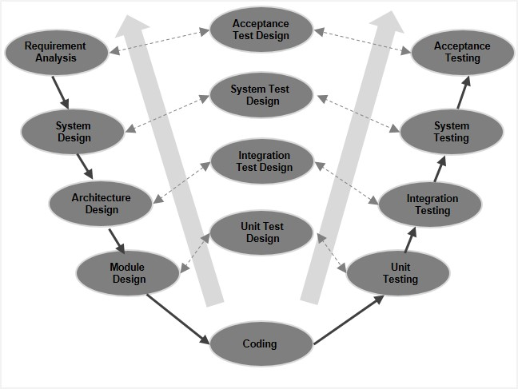

## V-Model - Verification Phases

* There are several Verification phases in the V-Model, each of these are explained in detail below.

### Business Requirement Analysis

* This is the first phase in the development cycle where the product requirements are understood from the customer’s perspective. This phase involves detailed communication with the customer to understand his expectations and exact requirement. This is a very important activity and needs to be managed well, as most of the customers are not sure about what exactly they need. The **acceptance test design planning** is done at this stage as business requirements can be used as an input for acceptance testing.

### System Design

* Once you have the clear and detailed product requirements, it is time to design the complete system. The system design will have the understanding and detailing the complete hardware and communication setup for the product under development. The system test plan is developed based on the system design. Doing this at an earlier stage leaves more time for the actual test execution later.

### Architectural Design

* Architectural specifications are understood and designed in this phase. Usually more than one technical approach is proposed and based on the technical and financial feasibility the final decision is taken. The system design is broken down further into modules taking up different functionality. This is also referred to as **High Level Design (HLD)**.
* The data transfer and communication between the internal modules and with the outside world (other systems) is clearly understood and defined in this stage. With this information, integration tests can be designed and documented during this stage.

### Module Design

* In this phase, the detailed internal design for all the system modules is specified, referred to as **Low Level Design (LLD)**. It is important that the design is compatible with the other modules in the system architecture and the other external systems. The unit tests are an essential part of any development process and helps eliminate the maximum faults and errors at a very early stage. These unit tests can be designed at this stage based on the internal module designs.

## Coding Phase

* The actual coding of the system modules designed in the design phase is taken up in the Coding phase. The best suitable programming language is decided based on the system and architectural requirements.
* The coding is performed based on the coding guidelines and standards. The code goes through numerous code reviews and is optimized for best performance before the final build is checked into the repository.

## Validation Phases

* The different Validation Phases in a V-Model are explained in detail below.

### Unit Testing

* Unit tests designed in the module design phase are executed on the code during this validation phase. Unit testing is the testing at code level and helps eliminate bugs at an early stage, though all defects cannot be uncovered by unit testing.

### Integration Testing

* Integration testing is associated with the architectural design phase. Integration tests are performed to test the coexistence and communication of the internal modules within the system.

### System Testing

* System testing is directly associated with the system design phase. System tests check the entire system functionality and the communication of the system under development with external systems. Most of the software and hardware compatibility issues can be uncovered during this system test execution.

### Acceptance Testing

* Acceptance testing is associated with the business requirement analysis phase and involves testing the product in user environment. Acceptance tests uncover the compatibility issues with the other systems available in the user environment. It also discovers the non-functional issues such as load and performance defects in the actual user environment.

# Software Engineering | Spiral Model

Last Updated: 28-05-2018

**Spiral model** is one of the most important Software Development Life Cycle models, which provides support for **Risk Handling**. In its diagrammatic representation, it looks like a spiral with many loops. The exact number of loops of the spiral is unknown and can vary from project to project. **Each loop of the spiral is called a Phase of the software development process.** The exact number of phases needed to develop the product can be varied by the project manager depending upon the project risks. As the project manager dynamically determines the number of phases, so the project manager has an important role to develop a product using spiral model.

The Radius of the spiral at any point represents the expenses(cost) of the project so far, and the angular dimension represents the progress made so far in the current phase.

Below diagram shows the different phases of the Spiral Model:  
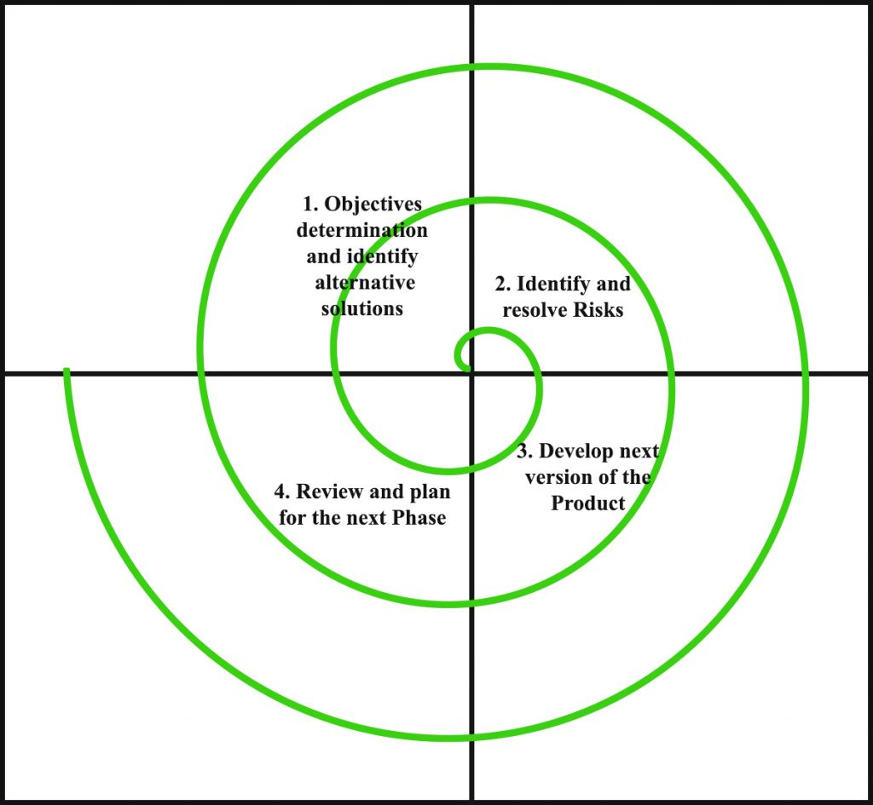

Each phase of Spiral Model is divided into four quadrants as shown in the above figure. The